Software Requirements Specification
for
Interactive Video Learning Using Affective Computing
Version 1.0 approved
Prepared by B.E. Grp 18-19/19
Computer Science And Engineering
22 September,2018
Table of Contents
Table of Contents ii

1. Requirement Analysis 1
1.1 Problem 1
1.2 Product Scope 1
1.3 Intended Application Users 1
1.4 Benefits 1
2. Functional Specification 2
2.1 Product Perspective 2
2.2 System Overview 2
2.3 System Functioning Details 3
3. External Interface Specifications 4
3.1 User Interfaces 4
3.2 Hardware Interfaces 4
3.3 Communications Interfaces 4
4. Technical Specifications 4
4.1 Performance Constraints 5
4.2 Operating Environment 5
4.3 Design And Implementation Constraints 5
4.4 Security Constraints 5

REQUIREMENT ANALYSIS

Problem

Most of the people prefer learning through online videos rather than learning offline, but there is no interaction in online learning with user. We don’t know whether user is engaged and enjoying watching the videos or getting bored or confused. It is necessary to provide guidance to the user learning online at that point of time as a virtual teacher who is there with each learner anywhere and anytime.

Product Scope

This project is the Implementation of Interaction in video learning using affective computing.
It aims at recognizing the level of learner's engagement in learning Process, learner’s mood and emotion and respond accordingly.
This project is to investigate the relationship between emotions and engagement in the online learning environment, and recognizing the learner’s emotions and giving suggestions to learner accordingly that can improve the efficiency of the e-learning process.

Intended Application Users

This document is intended to be read by developers, users, testers, project manager and documentation writers. This application can be used by anyone who is willing to learn through online videos.
Users can include:
- Students
- Teachers, Professors, etc.
- Engineers, Doctors, etc.
- Other Employees, Senior citizens.

Benefits

- It introduces a virtual teacher for every user anytime and anywhere.
- It enhances user interaction and engagement while learning online.
- It increases the concentration and efficiency of learner during learning process.
- It avoids boredom and confusion of users by providing simple solutions.

FUNCTIONAL SPECIFICATIONS

Product Perspective
Emotion recognition is one of the key steps towards affective computing. Many efforts have been taken to recognize emotions using facial expressions, speech and physiological signals. Making use of emotion recognition can help better user engagement, help user to solve on-time doubts and avoid boredom. We can describe this in short as “Instead of making learners engage in a subject they hate, we can enhance or create a subject that they’ll love through interaction.”
While user is watching video, this interactive learning platform aims to provide support for user’s doubts, emotions, interaction as a guide anytime and anywhere.

System Overview

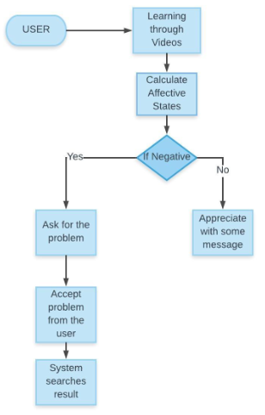

Below are the tasks on which this system will function:

• Facial Emotions Recognition
• Personal assistant to respond to certain type of emotions
• Providing answers to user about his/her queries from search engine over the internet.

System Functioning Details

Major Functioning of the system is described as below:

- System will recognize facial emotions of users watching the video.
- System analyses the affective state of the learners.
- System will interact with the user corresponding to the affective state.
- In case of any user query, system will provide the corresponding solution either in speech or text format.

External Interface Specifications

User Interfaces

- User will be provided with an application where he/she can watch the videos.
- While user watches the videos, user can interact with the system to clear out the doubts.
- User can feel engaged while interacting with the assistant.

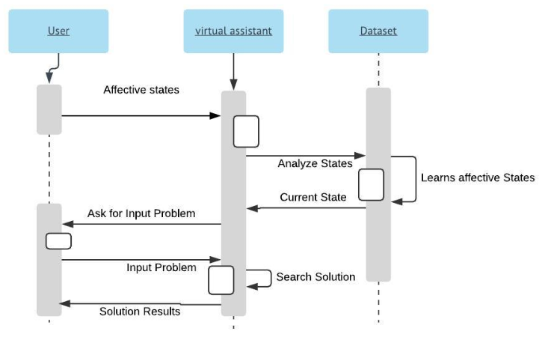

Hardware Interfaces
- Web camera integrated within a laptop/ External web camera
- Audio device

Communication Interfaces
- User requires good quality internet for video.
- User’s Camera interface to communicate with the system.
- Application will be accessed from server by user.

TECHNICAL SPECIFICATIONS

Performance Constraints
- Performance of the system highly depends on internet speed and quality of camera the device supports.
- The system will wait for input voice or text command after responding to user’s affective state, user must specify something in text/speech in order to benefit from the system.
- In case of an attempt where there are multiple users watching a video, System may work slowly.

Operating Environment
- This system needs web camera support for the Display unit.
- It allows both modes of communication text and speech. So any operating system which supports both will work fine.

Design and Implementation Constraints
- This system is provisioned to be built on the Python framework.
- It is a web application which makes integrates a BOT in a video viewing application
- We will be using DAISEE datasets to train the BOT.

Security Constraints
- User Identity is authenticated at the start of the system.
- So user must log out at the moment when user is not using the system to secure his/her personal information.

